The sequence in which the project report material should be arranged and bound should be as follows

- Cover Page
- Title Page
- Declaration by the Candidate
- Certificate
- Certificate by External Guide (Applicable for students doing project outside VELLORE INSTITUTE OF TECHNOLOGY, VELLORE)
- Abstract
- Acknowledgement
- List of Tables
- List of Figures
- List of Symbols, Abbreviations and Nomenclature
- Chapters of the Report
- Conclusion & Future Work
- References-APA FORMAT
- Appendices

Page Dimension and Binding Specifications
The dimension of the project report should be in A4 size.
Page Specification
Left Margin : 3.81 cm
Right Margin : 2.54 cm
Top Margin : 2.54 cm
Bottom Margin : 2.54 cm

The project report should be bound using flexible cover with below mentioned colored art paper. The cover should be printed in black letters and the text for printing should be identical.
Color of Art Paper | Total Number of Pages in the Report
White | Minimum of 60 pages

Page numbers
All text pages as well as program source code listings should be numbered using Arabic numerals at the bottom center of the pages.

Font
Times New Roman 12pt font should be used consistently throughout the text.
Captions for tables and figures can be in smaller fonts, but not smaller than 10pt.

Paragraphs
No paragraph should have its opening line at the bottom of a page. A clear, consistent, but not too large a separation must be provided between the paragraphs throughout the thesis.

Headings
Chapter Heading – Font Size: 16, Bold, Times New Roman
Section Heading – Font Size: 14, Times New Roman, CAPS
Subsection Heading – Font Size: 12, Times New Roman, CAPS
Line spacing
The line spacing used should be the same throughout the text, and can be chosen to be between one and a half. The lines in captions for figures and tables, Table of Contents, List of Figures, and List of Tables can be single spaced, if desired.

A project report on
<Times New Roman, Font 12, Italic>
TITLE OF THE PROJECT REPORT
<Times New Roman, Font 20, Bold, CAPS>
Submitted in partial fulfillment for the award of the degree of
<Times New Roman, Font 14, Italic>
B.Tech (Information Technology)
<Times New Roman, Font 22, Bold>

by
<Times New Roman, Font 14, Italic>
NAME OF THE CANDIDATE (Reg. No.)
<Times New Roman, Font 16, Bold, CAPS>



SCHOOL OF INFORMATION TECHNOLOGY & ENGINEERING

January, 2023
< Times New Roman ,Font size 12>

TITLE OF THE PROJECT REPORT
<Times New Roman, Font 20, Bold, CAPS>
Submitted in partial fulfillment for the award of the degree of
<Times New Roman, Font 14, Italic>
B.Tech (Information Technology)
<Times New Roman, Font 22, Bold>

by
<Times New Roman, Font 14, Italic>
NAME OF THE CANDIDATE (Reg. No.)
<Times New Roman, Font 16, Bold, CAPS>

SCHOOL OF INFORMATION TECHNOLOGY & ENGINEERING

Month, Year
< Times New Roman ,Font size 12>
DECLARATION
<Times New Roman, Font 14, Underlined, Bold, CAPS>

I here by declare that the thesis entitled “TITLE OF THE PROJECT” submitted by me, for the award of the degree of M.Tech (Software Engineering) is a record of bonafide work carried out by me under the supervision of <Guide Name>.
I further declare that the work reported in this thesis has not been submitted and will not be submitted, either in part or in full, for the award of any other degree or diploma in this institute or any other institute or university.
<Times New Roman, Font 12 >

Place: Vellore
Date: Signature of the Candidate
<Times New Roman, Font 12, Bold >

CERTIFICATE
<Times New Roman, Font 14, Underlined, Bold, CAPS>
This is to certify that the thesis entitled “TITLE OF THE PROJECT” submitted
by NAME OF THE CANDIDATE (<REG NO>), School of Information Technology & Engineering, Vellore Institute of Technology, Vellore for the award of
the degree M.Tech (Software Engineering) is a record of bonafide work carried out by
him/her under my supervision.
The contents of this report have not been submitted and will not be submitted
either in part or in full, for the award of any other degree or diploma in this institute or
any other institute or university. The Project report fulfils the requirements and regulations of
VELLORE INSTITUTE OF TECHNOLOGY, VELLORE and in my opinion meets the necessary standards for submission.

Signature of the Guide Signature of the HoD
<Times New Roman, Font 12, Bold > <Times New Roman, Font 12, Bold >

Internal Examiner External Examiner
<Times New Roman, Font 12, Bold > <Times New Roman, Font 12, Bold >

<It should be in the Company Letter Head>
Date: …………….…..>

CERTIFICATE BY THE EXTERNAL GUIDE
<Times New Roman, Font 12, Bold >
This is to certify that the project report entitled “TITLE OF THE PROJECT” submitted by <STUDENT NAME>(<Reg.No.>) to Vellore Institute of Technology in partial fulfillment of the requirement for the award of the degree of <Name of the degree> in <branch name> is a record of bonafide work carried out by him/her under my guidance. The project fulfills the requirements as per the regulations of this Institute and in my opinion meets the necessary standards for submission. The contents of this report have not been submitted and will not be submitted either in part or in full, for the award of any other degree or diploma in this institute or any other institute or university.
<Times New Roman, Font 12>

<Signature of the External Supervisor>
<Name> <Times New Roman, Font 12, Bold >
EXTERNAL SUPERVISOR
<Times New Roman, Font 12, Bold >
<Title of the Supervisor >
<Full address of the Institution / organization with e-mail id, phone no.>
<Seal of the Institution / Organization>
<Times New Roman, Font 12>

ABSTRACT
<Times New Roman, Font 14, Underlined, Bold, CAPS>
Electronic Business offers innovative ways of doing business through Internet.
Internet revolution has introduced number of advanced technologies to access
organizations all over the world in an efficient but simple manner. Internet traffic is
increasing exponentially as a result of wireless access, mobile computing and other innovative communication technologies.
<Times New Roman, Font 12>

i
ACKNOWLEDGEMENT
<Times New Roman, Font 14, Underlined, Bold, CAPS>
It is my pleasure to express with deep sense of gratitude to <Guide name>, <Designation, School name, Vellore Institute of Technology>, for his/her constant guidance, continual encouragement, understanding; more than all, he taught me patience in my endeavor. My association with him / her is not confined to academics only, but it is a great opportunity on my part of work with an intellectual and expert in the field of <area>.

I would like to express my gratitude to DR.G.VISWANATHAN, Chancellor VELLORE INSTITUTE OF TECHNOLOGY, VELLORE, MR. SANKAR VISWANATHAN, DR. SEKAR VISWANATHAN, MR.G V SELVAM, Vice – Presidents VELLORE INSTITUTE OF TECHNOLOGY, VELLORE, DR. RAMBABU KODALI, Vice – Chancellor, DR. PARTHA SARATHI MALLICK, Pro-Vice Chancellor and Dr. S. Sumathy, Dean, School of Information Technology & Engineering (SITE), for providing with an environment to work in and for his inspiration during the tenure of the course.

In jubilant mood I express ingeniously my whole-hearted thanks to Dr. Usha Devi G., HoD/Professor, all teaching staff and members working as limbs of our university for their not-self-centered enthusiasm coupled with timely encouragements showered on me with zeal, which prompted the acquirement of the requisite knowledge to finalize my course study successfully. I would like to thank my parents for their support.
It is indeed a pleasure to thank my friends who persuaded and encouraged me to take up and complete this task. At last but not least, I express my gratitude and appreciation to all those who have helped me directly or indirectly toward the successful completion of this project.
Place: Vellore
Date: Name of the student
<Times New Roman, Font 12, Bold >
ii
TABLE OF CONTENTS

LIST OF FIGURES ix
LIST OF TABLES xi
LIST OF ACRONYMS xii
CHAPTER 1
INTRODUCTION
  - BACKGROUND……………………………………………………………………..1
  - MOTIVATION…………………………………………………………………….....4
1.3 PROJECT STATEMENT 7
1.4 OBJECTIVES 7
1.5 SCOPE OF THE PROJECT 8
CHAPTER 2
LITERATURE SURVEY
2.1 SUMMARY OF THE EXISTING WORKS
2.2 CHALLENGES PRESENT IN EXISTING SYSTEM

CHAPTER 3

REQUIREMENTS
  - HARDWARE REQUIREMENTS
  - SOFTWARE REQUIREMENTS
  - BUDGET
  - GANTT CHART

CHAPTER 4

ANALYSIS & DESIGN

4.1 PROPOSED METHODOLOGY

4.2 SYSTEM ARCHITECTURE

4.3 MODULE DESCRIPTIONS

CHAPTER 5

IMPLEMENTATION & TESTING
5.1 DATA SET
5.2 SAMPLE CODE
5.3 SAMPLE OUTPUT
5.4 TEST PLAN & DATA VERIFICATION
CHAPTER 6

RESULTS

6.1 RESEARCH FINDINGS

6.2 RESULT ANALYIS & EVALUATION METRICS

CONCLUSIONS AND FUTURE WORK
REFERENCES

iv
LIST OF FIGURES
1.1 INFRA STRUCTURE BASED NETWORK 1
1.2 INFRA STRUCTURE LESS NETWORK 2
1.3 MOBILE AD-HOC NETWORK 4

iv

LIST OF TABLES
2.1 MULTIPATH ROUTING PROTOCOLS IN AMNETS 22
3.1 SIMULATION PARAMETERS 48

v
LIST OF ACRONYMS

MANET Mobile Ad hoc Network
WAP Wireless Access Point

vi
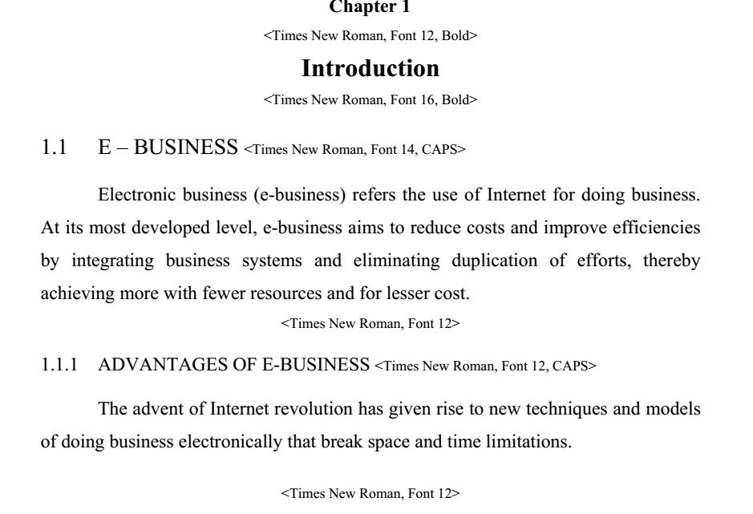

1
CHAPTER 2
LITERATURE SURVEY
2.1 SUMMARY OF THE EXISTING WORKS
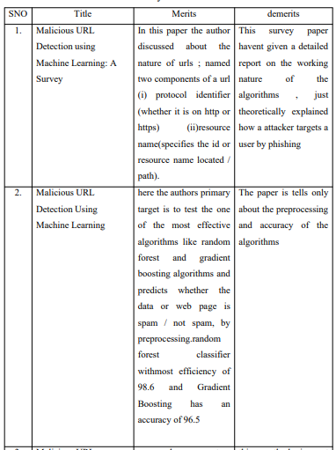

2.2 CHALLENGES PRESENT IN EXISTING SYSTEM

CHAPTER 3
REQUIREMENTS
  - HARDWARE REQUIREMENTS
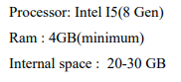
  - SOFTWARE REQUIREMENTS
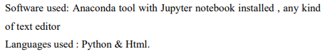
  - BUDGET
Procured Items/Components for the Project work | Total Cost
Item 1
Item 2
Item 3
Total Budget (INR)
Note: Please Refer the Appendices A for more details and select suitable items as per your project requirements.
  - GANTT CHART
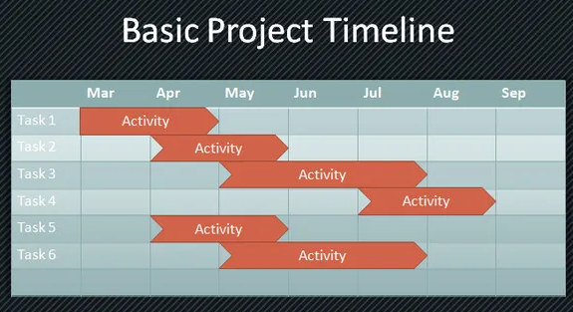
Acitivity | Description of the Activity | Guide Remarks
1
2
3

Chapter n
< Times New Roman, Font 12, Bold>
Conclusion & Future Work
< Times New Roman, Font 16, Bold>
This chapter should summarize the key aspects of your project (failures as well as successes) and should state the conclusions you have been able to draw. Outline what you would do if given more time (future work). Try to pinpoint any insights your project uncovered that might not have been obvious at the outset. Discuss the success of the approach you adopted and the academic objectives you achieved. Avoid meaningless conclusions, [e.g. NOT “I learnt a lot about C++ programming”]. Be realistic about potential future work. Avoid the dreaded: “All the objectives have been met and the project has been a complete success”. You have to crisply state the main take-away points from your work. Describe how your project is performed against planned outputs and performance targets. Identify the benefits from the project. Be careful to distinguish what you have done from what was there already. It is also a good idea to point out how much more is waiting to be done in relation to a specific problem, or give suggestions for improvement or extensions to what you have done.
Future scope of the work for improvement may also be included

42
Appendices
< Times New Roman, Font 12, Bold>

Appendices are provided to give supplementary information, which is not included in the main text may serve as a separate part contributing to main theme.
- Appendices should be numbered using Arabic numerals, e.g. Appendix 1, Appendix 2 etc.
- Appendices, tables and references appearing in appendices should be numbered and referred to at appropriate places just as in the case of chapters.
- Appendices shall carry the title of the work reported in it and the same title shall be used in the contents page also.
Appendices A

Items listed below are for example only | Total Cost | In kind or Match (what you already have) | Requested

Facility Expenses
Utilities
maintenance (cleaning)
Internet connection

Total Facility Expenses

Supplies
office supplies (provide details such as $20 per month x 12 months)
Workbooks
arts & crafts supplies
Software
classroom supplies (for students and teachers)

Total Supplies

Equipment
desktop computers
laptop computers
Printer
Scanner
Chairs
digital camera

Total Equipment

Contractual
Outside evaluator for program
Experts we hire to come train our personnel

Total Contractual

Communications
Telephone
long distance
cellular phones
Postage
Internet

Total Communications

Other Expenses

Total Non-Personnel Expenses
Total Direct Costs (personnel and non-personnel expenses)
Total Project Costs/Total Request

43
REFERENCES
<Times New Roman, Font 16, Bold, CAPS>
(ALL REFERNCE SHOULD BE IN APA FORMAT)
Eckart, C. (1951). Surface waves on water of variable depth, Wave Rep. 100, Scripps Inst. of Oceanogr., Univ. of California, pp.99. <For referring reports>

Hasselmann, K., W.H. Munk and G.J.F. MacDonald (1963). Bispectra of Ocean Waves, In: M. Rosenblatt (ed.), Time Series Analysis, John Wiley Sons, p. 125, NewYork. <For referring from books edited from a collection of different papers>.

Stoker, J.J. (1957). Water Waves. Interscience, New York. p. 520.
<For referring book>

Tatavarti, Rao V.S.N. and D.A. Huntley (1987). Wave reflection at Beaches. Proc. Canadian Coastal Conference, Quebec City, pp. 241-255, Canada.
<For referring conference proceedings>
Wallace, J.M. and R.E. Dickinson (1972). Empirical orthogonal representation of time series in the frequency domain, Part I: Theoretical considerations, J. App. Meteorology, Vol. 11, No. 6, pp. 887-892. <For referring journals>
<Times New Roman, Font 12>

